**Data Analysis and Visualization -Practice -4**

**VLOOKUP in Excel**

**Example 1 – Finding Brad’s Math Score**

In the VLOOKUP example below, I have a list with student names in the left-most column and marks in different subjects in columns B to E.

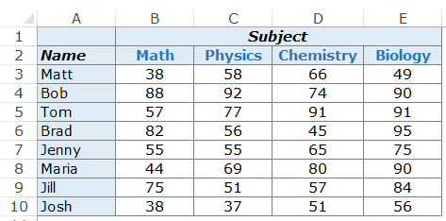

From the above data, we need to know how much Brad scored in Math.

From the above data, I need to know how much Brad scored in Math.

Here is the VLOOKUP formula that will return Brad’s Math score:

=VLOOKUP("Brad", $A$3:$E$10,2,0)

The above formula has four arguments:

* **“Brad:** – this is the lookup value.
* **$A$3:$E$10** – this is the range of cells in which we are looking. Remember that Excel looks for the lookup value in the left-most column. In this example, it would look for the name Brad in A3:A10 (which is the left-most column of the specified array).
* **2** – Once the function spots Brad’s name, it will go to the second column of the array, and return the value in the same row as that of Brad. The value 2 here indicated that we are looking for the score from the second column of the specified array.
* **0** – this tells the VLOOKUP function to only look for exact matches.
* Here is how the VLOOKUP formula works in the above example.
* First, it looks for the value Brad in the left-most column. It goes from top to bottom and finds the value in cell A6.
* 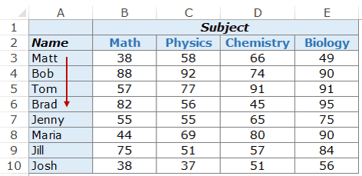
* As soon as it finds the value, it goes to the right in the second column and fetches the value in it.
* 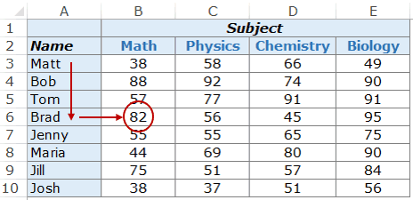
* You can use the same formula construct to get anyone’s marks in any of the subjects.
* For example, to find Maria’s marks in Chemistry, use the following VLOOKUP formula:
* =VLOOKUP("Maria",$A$3:$E$10,4,0)
* 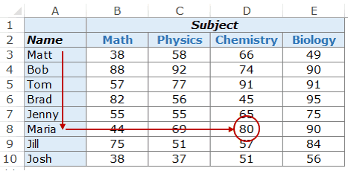
* In the above example, the lookup value (student’s name) is entered in double quotes. You can also use a cell reference that contains the lookup value.
* The benefit of using a cell reference is that it makes the formula dynamic.

For example, if you have a cell with a student’s name, and you are fetching the score for Math, the result would automatically update when you change the student’s name (as shown below):



### Example 2 – Two-Way Lookup

In Example 1 above, we hard-coded the column value. Hence, the formula would always return the score for Math as we have used 2 as the column index number.

But what if you want to make both the VLOOKUP value and the column index number dynamic. For example, as shown below, you can change either the student name or the subject name, and the VLOOKUP formula fetches the correct score. This is an example of a two-way VLOOKUP formula.

This is an example of a two-way VLOOKUP function.



To make this two-way lookup formula, you need to make the column dynamic as well. So when a user changes the subject, the formula automatically picks the correct column (2 in the case of Math, 3 in the case of Physics, as so on..).

To do this, you need to use the [MATCH function](https://trumpexcel.com/excel-match-function/) as the column argument.

Here is the VLOOKUP formula that will do this:

=VLOOKUP(G4,$A$3:$E$10,MATCH(H3,$A$2:$E$2,0),0)

[](https://eb2.3lift.com/pass?tl_clickthrough=true&redir=https%3A%2F%2Frtb-us-west.linkedin.com%2Flax%2Fclk%3Ftrk%3DCwEAAAF9961lfmG2neXk8YZWl-s40L-teoB3LzYGuTU9ZHBljNOzg5Xq9UbtQHStqvWWczoQ28qQYWzjguTKz11Ir9GhVCjkukjInQT4B3SYVE7XeuVER4oj1jGgb1tpImGY904SIgSLvQ0zXR4zsFwW9Kk2_ZEOC1ZiFKN8sXnplyMSHfQ2tqdAC6bbryuwyF6oCByYBLEu5zoVbKdu4y8rzKp1Z8NivUlVuUVTIFgHCSTKp5MY1WDs_2qrGaaupJ06kecHtX1W1NK6iawF0wakWmhs30sd4njQhlVx1pVvy2RIDpA2ah6O7Zn7e3faX63TdWs46C7wN_QFzRyQXXyCKvMEWD3IU4TVmEfQZFn6qONa74mxcKKBxttgyFv9VyYTdldbXU4yYXE6W3wv1UGIWVi5JWOu3wNIiFknAP33qKUEQ_acJjF-qm5cm7iiWwg5_mRHH0EBTEJC1fPEOwLTLL-hLJAxyDb3LIS8me3oESrM4RwIKb9vmkN25QlTZzRsOpxbrTj8W7ryvUAmd_ViUi-y6mPVuRW5QGcVuqEIIEBYWWmLKCQjaCoSbe_GeATQcucNms1vQh3cMaTYI5vL5CVB532RKmg_fB1wHzZWLZde8t3a5TShcWSSa2N1Mhrf94vzpv7gQ4abkv3S5IVdvP3NbPdxV5qeD8zgteAK4Eryctd26ApSwwifNPzxMg4KTrsWEWjjsrw7pgjFWWG8cS6EEfCLGeQoBQMB6yGvjnKliVIA4Fc6nm9X6lQuX6daN3_1WTbRpmiAuSrffPUqUqSCScMCRh6JdR8BypLqriPBqrwizevxAVi1a2XVMGjL8O7f2a1atvMJvie8rhcrj24mcMQdNoT8C2VWAwTDWK88yka5NZdJUvp6BbtJUQhvMFYZxg0Uzm5Ob4u1HLeYHPvQnfCibcMPULmCjpy5jBXiKnAkSc_zxfoY-hCJZbsmt8LuY5IiPCK-Q_FM3WsRx5yE1cu83nF6VLXIe7zz9zuV6eu2f91IH2G-qmwJGGa6NBU5sDdySwCBedr6ZPSfqDzvT3YeAJpA0wLDALkUOnYoOLtFhDc8Y8aSkDr7IDhCO10nfDbh8cemNzzlVJidIaKeu061fMJ06JV5OkfER5n5RmP1fc5UDOZ72iLwPNvMc_iB4uQoBgupPvadmGGLWtoEq0_1zo0KVhBS8PG8KfuVDtUWCIHGPpjbyyHRjKUpnnrPGsJ58wkL1AbBxMWneuI_SJ1vWEuFeo_1hyDC5NZBy4lY2crEbKTD-DQelwqhgxlSjhQq8UTjI7papDk8VoHAr0mAoZXIdX85-eSKZQIORnZSGv6QL7UDeqxDr2j0W0h7Kr_VUWzTqn35O7GGuEs7_Uf7QOE06CTNfMRVlU3dV2zTxnuQhwhcPG08oUas-Hxz1XUwm43qdv0RhtfIIS8A-WXkRQOrLxlkhLbbYVSD1TScT_zzjvq1XzxcJP5Zq6PGjMpeWJmyRGPDthbCWGINZGa9vugXNcjcRupLtbaNoY3dPZmCdD8IJc0%26action%3Dclick%26laxrid%3D208fc04e-b843-446e-a594-605f24ba35f6%26laxbid%3D2%26eid%3D3%26crtype%3Dvid%26laxerid%3D13567901026777003610%26adfmt%3D6%26urle%3DCwEAAAF9961lgqy-hdkSMdAVLpZvF5_XIJnTss2H8D8vHqty9_P8r1EE7eqh9yzK9fOJRvRtFUnvj6tsinrElNcScdpH84OsEwvSX9kSAaSBDCDN3WmNwOKSs2yuUfVNBQ7zrO4sQMeqlVuIyqHGwP771dILb4A0mSxggTmkDCpO6Eb9btddO1WhfGtLp7T6jLKEI6vRQLiOklSub-kph_jrJFhAhK_H_oEJnWfwiqd2otQBRispeIkzvG_nJt6uvXJIrTJDuaKzg-DW9C3WWYTSmghz%26urlhash%3D3ezg&ss=39&bc=1.085&pr=0.510976&brid=567162&bmid=6250&biid=6250&aid=13567901026777003610&bcud=1085&sid=66552&ts=1640537875&cb=17042" \t "_blank)

The above formula uses MATCH(H3,$A$2:$E$2,0) as the column number. MATCH function takes the subject name as the lookup value (in H3) and returns its position in A2:E2. Hence, if you use Math, it would return 2 as Math is found in B2 (which is the second cell in the specified array range)

### Example 3 – Using Drop Down Lists as Lookup Values

In the above example, we have to manually enter the data. That could be time-consuming and error-prone, especially if you have a huge list of lookup values.

A good idea in such cases is to [create a drop-down list](https://trumpexcel.com/excel-drop-down-list/) of the lookup values (in this case, it could be student names and subjects) and then simply choose from the list.

Based on the selection, the formula would automatically update the result.

Something as shown below:



This makes a good dashboard component as you can have a huge data set with hundreds of students at the back end, but the end user (let’s say a teacher) can quickly get the marks of a student in a subject by simply making the selections from the drop down.

How to make this:

The VLOOKUP formula used in this case is the same used in Example 2.

=VLOOKUP(G4,$A$3:$E$10,MATCH(H3,$A$2:$E$2,0),0)

The lookup values have been converted into drop-down lists.

Here are the steps to create the drop down list:

* Select the cell in which you want the drop-down list. In this example, in G4, we want the student names.
* Go to Data –> Data Tools –> Data Validation.
* In the Data Validation Dialogue box, within the settings tab, select List from the Allow drop-down.
* In the source, select $A$3:$A$10
* Click OK.

Now you’ll have the drop-down list in cell G4. Similarly, you can create one in H3 for the subjects.

### Example 4 – Three-way Lookup

What is a three-way lookup?

In Example 2, we’ve used one lookup table with scores for students in different subjects. This is an example of a two-way lookup as we use two variables to fetch the score (student’s name and the subject’s name).

Now, suppose in a year, a student has three different levels of exams, Unit Test, Midterm, and Final Examination (that’s what I had when I was a student).

A three-way lookup would be the ability to get a student’s marks for a specified subject from the specified level of exam.

Something as shown below:



In the above example, the VLOOKUP function can lookup in three different tables (Unit Test, Midterm, and Final Exam) and returns the score for the specified student in the specified subject.

Here is the formula used in cell H4:

=VLOOKUP(G4,CHOOSE(IF(H2="Unit Test",1,IF(H2="Midterm",2,3)),$A$3:$E$7,$A$11:$E$15,$A$19:$E$23),[MATCH](https://trumpexcel.com/excel-match-function/)(H3,$A$2:$E$2,0),0)

This formula uses the CHOOSE function to make sure the right table is referred to. Let’s analyze the CHOOSE part of the formula:

CHOOSE(IF(H2=”Unit Test”,1,IF(H2=”Midterm”,2,3)),$A$3:$E$7,$A$11:$E$15,$A$19:$E$23)

The first argument of the formula is IF(H2=”Unit Test”,1,IF(H2=”Midterm”,2,3)), which checks the cell H2 and see what level of exam is being referred to. If it’s Unit Test, it returns $A$3:$E$7, which has the scores for Unit Test. If it’s Midterm, it returns $A$11:$E$15, else it returns $A$19:$E$23.

Doing this makes the VLOOKUP table array dynamic and hence makes it a three-way lookup.